**Oracle System: OFD Employees in FISERV**

FISERV is using Oracle database for the employees can book their Personal expenses through concur by posting an invoice into Concur.(JE upload T code ?)

Prerequisites: Based on Employee location SAP needs Proxy/Dummy costcenter and Employee information, with this data Table TVARVC variant(Z-EDS_FDC )will push employee to create in SAP

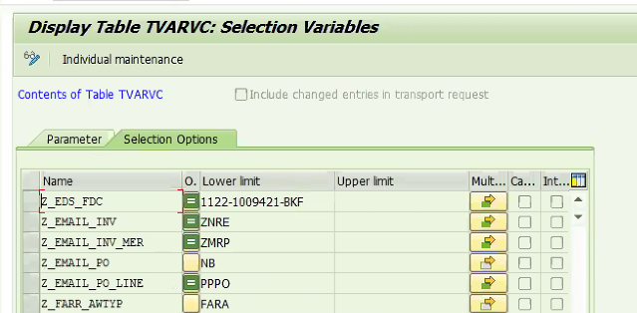.

1. Concur Feed: In the first step all the Oracle data will be created in the SAP Workday (FISERV) Example: Employee Information, Costcenter(Proxy), Org Key, and for a Particular company code.
2. Once Proxy cost center is created in sap and JE upload will have this cost center for posting ZN Doc invoice or OFD employee invoice with Trading partner.

**SAP**

**ZN Document**

It will be used for Personal expense booking for OFD employees (From Oracle database).

ZN document is mainly used for Intercompany postings such as Employees belonging to one company code and payments will be done with another company code.

At the time of ZN document creation:

Accounting Entries **(Nikhil Go to Se16n > BKPF Table > Choose ZN doc type and Pick the Document Number > Use T code FB03 and observe the Invoice and paste the Document here)**

Example:

Vendor Account(10081860) Credit( Balance sheet account)  
Concur clearing account(151925) debit(Profit and Loss Account) **check in t code Fs00 co code 2313**

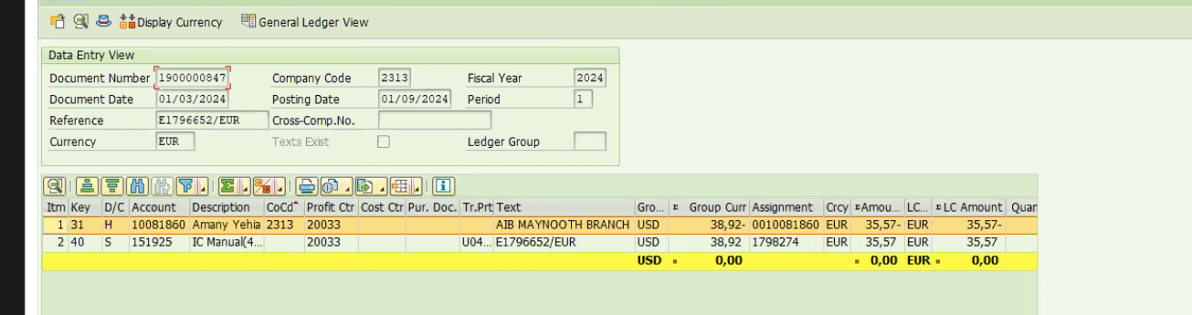

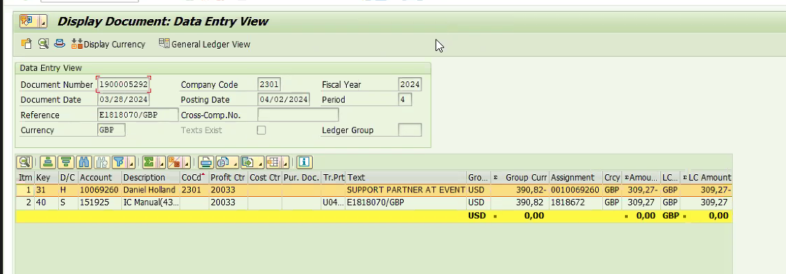

**Clearing invoice:**

ZN document will be cleared through APP (F110), and

at the time of posting ZP document Creation.

Accounting Entries:

Vendor A/C Debit

Out Going Bank A/c Credit

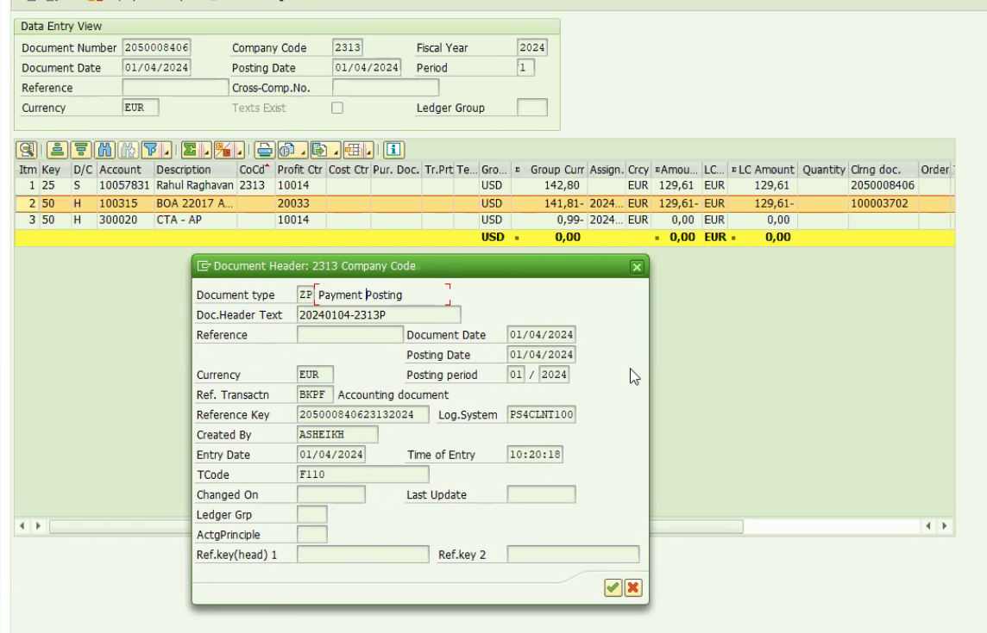

**ZM document type:**   
ZM document type used to Book expenses.

ZM Document type Postings are Multi-postings (IC and Normal transactions).

For instance: An employee has utilized his own expenses on the name of the Company ( Meals, Hotel, fuel or Client meeting and internal meeting etc..) and he will get reimbursed by posting an invoice through concur into SAP.(Using JE upload t code: Z_FGL_WERCCA)

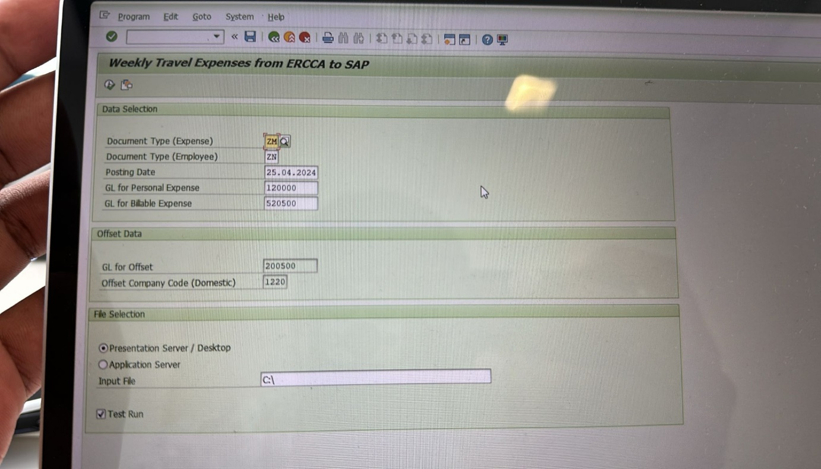

In this posting various Configured GL accounts and ZM document will be tackled.  
(Note: Every expense type has their own GL account)

OFC employees will use this ZM Document my type mainly and this will turn into ZN for payments.

At the time of IC postings:

ZM document postings will be transferred to ZN document type as follows.

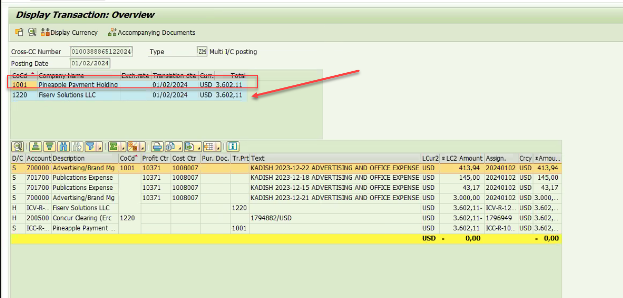

Then the ZN will be cleared with ZP.

Vendor Open items: FBL1N

These items are yet to clear items.

ZN will be cleared with ZP

**Currency Logic:**

All concur postings will be paid of through Company code home currency.

For Instance: A employee has traveled internationally, and he has used money from his pocket and that amount should be paid with Company code currency.

We have an option to convert the currency factor in Concur it self.

Like: Employee From India and he has used his money in US

USD= INR

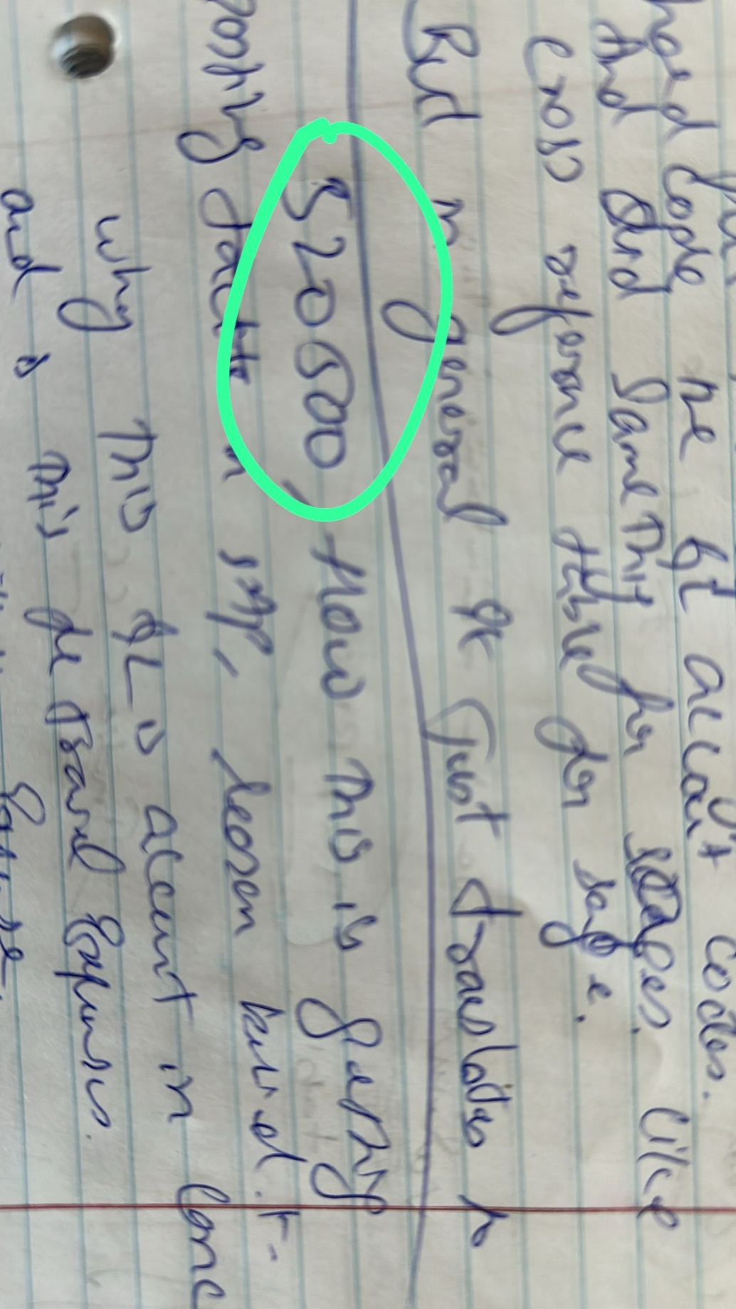

1 This GL account is used for all Billable travel expense reimburse and its hard coded

2 This GL account type is Expense and it P&L account

Workday/Mini master data:

Concur mainly uses the Mini master data information to create the Profile and give the access to concur profile;

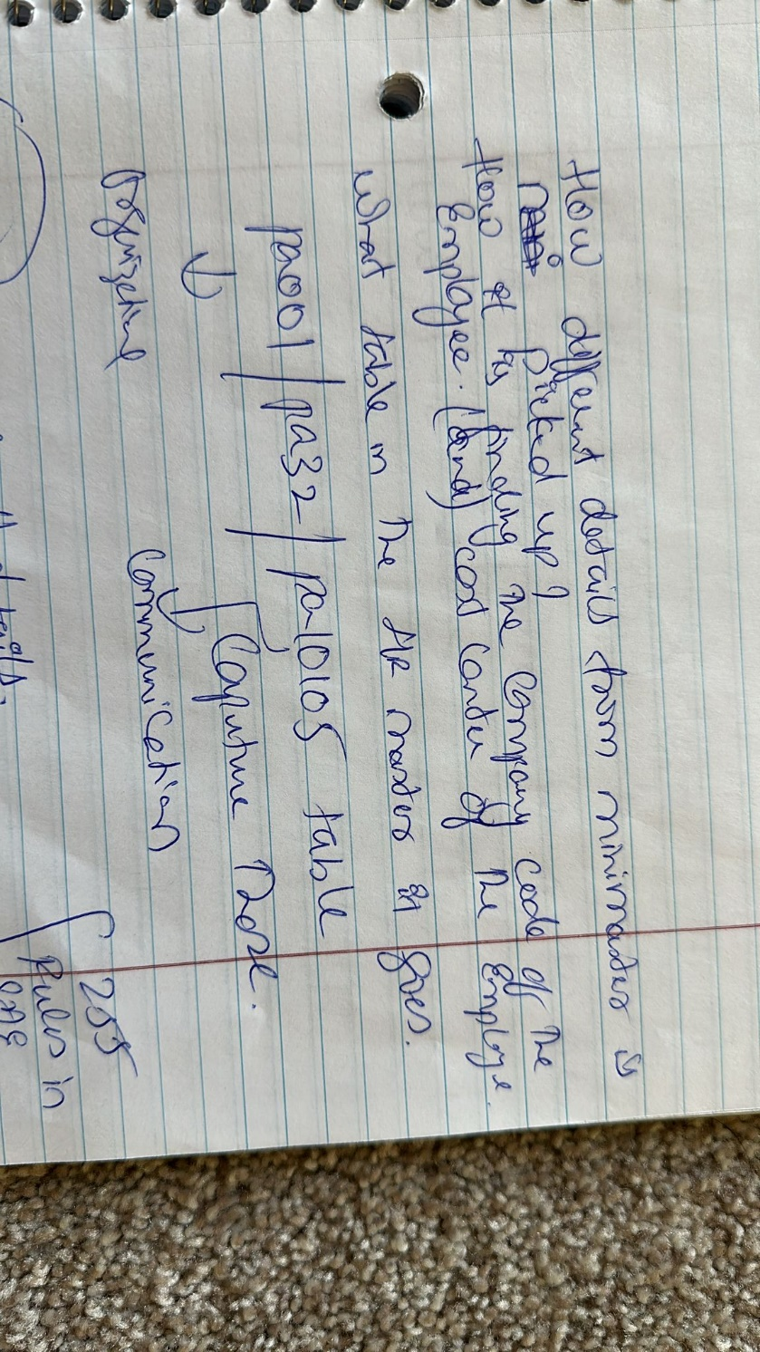

0001 Organizational assignments Info type or Table PA0001

T code: PA20

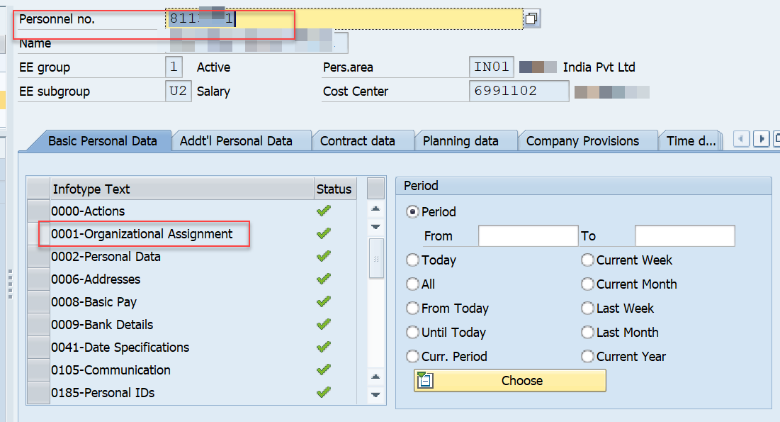

Pa001 infotype will give below info for Concur profile creation in Concur

First name

Last name

Start date

End date

Personnel/Employee number

Costcenter, etc

Mini Master/HR Master data:  
105 Info Type or PA0105 Communication:

T code PA20

Infor type 105 will gives the Communication information to Concu profile,  
  
Email information:  
Start date and end date of email address  
SAP Id

